THE MYSTERY OF THE DIVINE GODHEAD

AND

THE DUAL NATURE OF JESUS CHRIST

By Dr. Paul Richardson

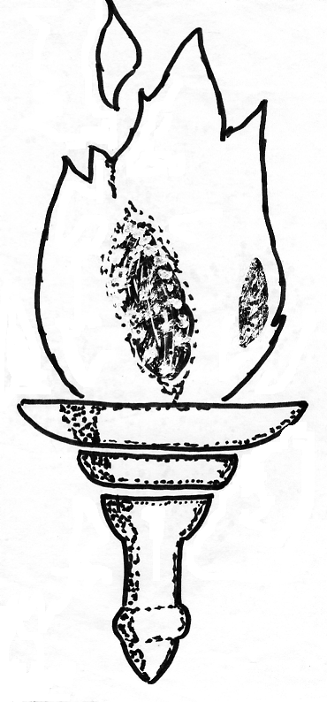
Torch of Truth Christian Publishing
2800 Blendwell Rd.
Richmond, Virginia 23224

DrPaulRich@Juno.Com
1 (804) 276-4709
http://fgcfi.tripod.com

Printed in the United States of America for Worldwide Distribution
First edition 3,000 copies —March 2008 A.D.

Copyright Privileges

Permission is hereby granted to anyone to reprint, quote, or otherwise use the contents of this book or any part of it to spread the Good News of Jesus Christ. I hope and pray that someone will even translate it into other languages, especially for the Native Americans. Acknowledgment of authorship will be appreciated, and please let me know. Thanks.
Websites:
http://fgcfi.tripod.com/
http://www.geocities.com/josephofjoseph/
http://www.netministries.org/see/churches/ch03916
http://www.geocities.com/spiritofti/
http://www.ourchurch.com/view/?pageID=34303

PURPOSE
A recent poll reported that in the U.S.A. over 16% of the people are atheists, agnostics, and other non-believers ! ! !
About 5% are part of some false world religion, about 4% are in the cults, 24% are Catholics, 25% are of the old main line denominations, and only 26. 3% are of Evangelical Churches. That is a lot of unsaved souls.
Therefore, the aim of this book is to persuade people to believe in the God of the Holy Bible, and to help my fellow Christians, who have grabbled with the great mystery of the Divine Godhead –--namely, how can 1+1+1 =1 ?
“And without controversy great is the mystery of godliness: God was manifest in the flesh, justified in the Spirit, seen of angels, preached unto the Gentiles, believed on in the world, received up into glory.” I Tim. 3: 16
DEDICATION
This book is dedicated to every man, woman, boy and girl, who want to understand and know the Lord.
“Thus saith the Lord, Let not the wise man glory in his wisdom, neither let the mighty man glory in his might, let not the rich man glory in his riches: But let him that glorieth glory in this, that he understandeth and knoweth me, that I am the Lord which exercise lovingkindness, judgment, and righteousness, in the earth: for in these things I delight, saith the Lord.” Jer. 9:23-24
Some of you may feel that you already know God in your heart, but have just not been able to articulate your concept of the Divine Godhead; well, now you will have more confidence when you try to share this difficult doctrine with others.
It is my earnest prayer that this digest of Truths from our Holy Bible and even extra inspirational revelation from the Holy Ghost will be a great blessing to you.

EXPRESSION OF APPRECIATION
First, to my beloved wife, Dr. Faye Richardson, who always cooks, takes care of me, and bears with me as I write --- sometimes day and night.
To Rev. Dr. Carol Stratton, who proofread and corrected all the many errors in it for me.
To Rev. Anthony (Eddie) Karpowich, who assisted in sorting out and collating the pages.

For extra copies please contact:

TORCH OF TRUTH CHRISTIAN PUBLISHING
2800 BLENDWELL RD.
RICHMOND, VA. 23224

INTRODUCTION
The carnal mind is horizontal thinking but the spiritual mind does vertical thinking.
Saints mind heavenly things, but sinners mind earthly things, which is why virtually the whole world is ignorant of God, which ought to be reason enough to justify this book.
I almost wonder if what Paul said to the pagans about “The unknown god,” might not apply even to many churches today:
Acts 17: 22 Paul stood in the midst of Mars' hill, and said, “Ye men of Athens, I perceive that in all things ye are too superstitious. For as I passed by, and beheld your devotions (religious objects) I found an altar with this inscription. TO THE UNKNOWN GOD. Whom therefore ye ignorantly worship, him declare I unto you.”
This is the very opposite of God’s ideal: “For the earth shall be filled with the knowledge of the glory of the Lord, as the waters cover the sea.” Hab. 2:14
Have you ever wondered, “Who is God?” This book endeavors to address this most important of all questions. We really need to know God is. For how can one's soul be saved if they don't even know God? Or how can you worship a God you do not understand?
We need to take into account everything the Bible says about God in arriving at our conception of Him. And we must consider all passages of Scripture and make sure that we do not clash with any plain statement therein.
Yes, God is awesome, unfathomable, and leaves us speechless.
Inasmuch as earthly language falls short in describing heavenly things, please bear with me as I grope for the best human words to explain the Supreme Being that we call “ Our Father, which art in heaven...”
There is a limitation to human terminology and we cannot reduce God to human language. There just aren't enough adequate words in the dictionary to properly describe Him.
So I think it is permissible to use some modern terms as long as they express the proper meanings.
I am sure that God's Being is simple enough to Himself, but He is utterly amazing to us.
To say that the Divine Godhead is a great mystery is an understatement!
If we can see that the natural creation of the universe and even here on our little planet, earth life is far from simple, why would we expect God to be simple?
God is completely above and beyond our finite comprehension. It is like an ant trying to figure out a man.
We cannot understand Him with our human intellect, but we sure need, hunger and long for Him. We love Him and yearn for more of Him.
Even throughout eternity, we will never fully comprehend God, for how can a finite mind encompass an Infinite Supreme Being. It is like trying to contain the ocean in a little thimble.
First, we need to get our “head” out of the way. Using left-brained, Western Rationalism rather than inspirational revelation contributes to the problem.
Man can not know God by his analytical, logical, reason alone, yet even a little child can understand with his heart that God is good and that “God is love.” I John 4:8
THE ATTRIBUTES OF GOD
Well, God is the first fact, the universal and ultimate truth.
The God of the Inspired Scriptures is the one and only true and living God and He has many Names therein.
The profound principal of our Bible is: “Hear, O Israel: The Lord our God is one Lord.” Deut. 6:4 Amen and amen!
God is the causeless “First Cause” of all other causes and effects, the “I AM THAT I AM.”, the origin of all existence, and the Author of all reality.
He always was, now is, and forever shall be. Heb. 13:8
He received His existence from no other, as Isaiah 44:6 says, “Thus says the Lord, the King of Israel and His Redeemer, the Lord of host; I am the First and I am the Last, and besides Me there is no God.”
But God is not a “has – been” Creator; He has, is, and always shall continue to be the Creator, speaking new worlds into existence and populating them with His living creatures. Heb. 1:2
God is unmade, unborn, and not produced.
He is self-existing and exists from Himself without beginning or ending.
Nothing existed before God and nothing ever preceded Him.
God is the prime source of all things --- visible and invisible.
He cannot die because He is life itself. God lives and nothing is as sure as God.
God is our benevolent Heavenly Parent. And He is real unto my soul.
Scripture always refers to God in the masculine — He, Him, and His, never She, Her or Hers.
God is the Author of male and female and yet He is above mere gender.
Our Creator is far above all human notions and earthly experience.
But God is not some remote Being a billion miles away, preoccupied with lofty cosmic matters.
He is a real, relevant, never too late - always on time –Faith God available for you and me right now!
God is unchanging and unchangeable, and His word is forever settled in heaven.
He is all-knowing, all-seeing, all-hearing, all-wise, and all mighty. His understanding is perfect.
God cannot learn anything and He is never surprised.
He has always known everything that has happened, is happening, or ever will happen.
He is the Ancient of Days, but fresh every morning. He never sleeps, and needs no rest.
God is love and light and life unto our soul.
He is good without mixture ---all good, only good, and always good, so glorify Him forever.
God is so strong and mighty. He is warm and you can feel His love and share the experience with others.
He set up the physical laws of nature such as energy, gravity, and electricity and they usually work the same way all the time, but He can temporarily suspend the laws of nature anytime He sees fit in order to perform a miracle for one of His own who has faith in Him.
God can instantly or gradually create missing human body parts.
God supersedes our normal perception and the natural senses. He transcends human comprehension and exceeds mortal consciousness.
What can we compare Him to? God is absolutely incomparable!
He is a wheel in a wheel, or as Ezek. 1:16 says, He works “as it were a wheel in the middle of a wheel.”
He is an inexhaustible Spiritual Sun. Ps. 84:11
God is everywhere at once, and in Him we live and move, and have our being. Ac. 17:28
GOD IS TIMELESS
Time is important. Businessmen say that time is money. Clocks and calendars mathematically measure time for us. Time comes in seasons: winter, spring, summer, and autumn.
Time is based on the revolutions of the earth upon its axis and as the earth rotates around the sun making a complete year.
- A moment is an indefinite short period of time.
- An instant is a very short period of time such as the beat of heart or the blink of an eye.
- An event is something that happens in a given place at a given time.
- A duration is the period of time during which something continues to be or happens.
- An age refers to an indefinite period of time marked by some divine dispensation or special characteristics.
To us, time moves along from the past, to the present, to the future. History is time past and really means “his story.”
The Old Testament was the New Testament concealed, while the New Testament is the Old Testament revealed.
Our perception of time can change: we say time stands still, flies by, or where did the time go, or we had a great time, or we are losing time, etc.; but the fact is, we can never control time, so forget about “Time Machines.”
Time can appear to our consciousness as moving along slow or fast as to the sequence of events around us.
When I am traveling in my car to a far destination, it seems to take so long going, but on the way back, time seems to pass faster.
Time seems to move more slowly during childhood. Remember how a summer day seemed to last forever. But older people look back and feel that the past decade was only months ago.
People, when they were drowning or near death say that their whole life-review flashed before them in an instant.
Some people who have out of body experiences in either Heaven or hell get the impression that the duration of time was longer than it really was, as if the time expands or contracts like a squeeze box.
Our life span is a limited probationary state to give us an opportunity to exercise our free moral agency — to choose between God and the devil and between good and evil.
The sinner man does not want to believe in God, accountability to Him, Judgment Day, or in Heaven and hell. He prefers to confine his thinking to his present life in this world only.
Normally, people wish to live as long as they can, even indefinitely:
- The Pharaohs built great pyramids to ensure and provide for their afterlife but all in vain, for eternal life is only found in Christ.
- Fools have traversed the jungles of the continents searching for the fabled, “Fountain of Life” but all in vain, for “He that hath the Son hath life and he that hath not the Son hath not life.”
I Jn. 5:12
- Today there are companies that will freeze your body at death for many thousands of dollars in the slimmest of hope that you may later be revived. This pseudo-science scam is called “Cryonics.”
We should be more concerned with the spiritual quality of our life rather than how long we can stretch it out.
The values, concepts and pursuits of the natural man are as silly as a blindfolded child trying to hit a suspended piñata.
This world is turned upside down, but the Gospel sets it upright. Ac. 17:6; Eccl. 3:1-8 says that there is a time and a season for every purpose under the heaven: A time:

To be born
to die;
to plant,
to pluck up
to kill
to heal
to break down
to build up;
to weep
to laugh
to mourn
to dance
to cast away stones
to gather stones
to embrace
to refrain from embracing;
to get
to lose
to keep
to cast away
to rend
to sew
to keep silence
to speak;
to love
to hate
of war
a time of peace

Many people are busy spending time on unimportant things.
Sinners are really like zombies — living corpses, because they are spiritually dead while they are physically alive. I Tim. 5:6
You can be whatever you want to be spiritually— it's your free choice. But God already knows which way you will go. He is never surprised by anything that happens, because He is already aware of everything. This is the mystery of the foreknowledge of God, but it is not pagan fatalism.
What we are now, spiritually, we shall be eternally. What we shall be in eternity is what we presently are spiritually.
HOW DOES GOD HIMSELF RELATE TO TIME?
God created space, energy, matter, and time; so time is a part of God's creation.
“For thus saith the high and lofty One that inhabiteth eternity, whose name is Holy; I dwell in the high and holy place, with him also that is of a contrite and humble spirit, to revive the spirit of the humble, and to revive the heart of the contrite ones.” Isa.57:15
God never began to exist and He will never go out of existence. The eternal God was in the beginning, now is, and will forever be.
“And Moses said unto God, Behold, when I come unto the children of Israel, and shall say unto them, The God of your fathers hath sent me unto you; and they shall say to me, What is His name? What shall 1 say unto them?
“And God said unto Moses, I AM THAT I AM: and He said, Thus shalt thou say unto the children of Israel, I AM hath sent me unto you.” Ex. 3:13-14
God is not confined to any single point in time, nor does He experience temporal succession.
Theologians and philosophers say that God is altogether “above and outside” of time to indicate His divine timelessness. He is not limited to anything else either.
God focuses His gaze on everything in time as a single present. In fact, to God, eternity past and eternity future is like “ONE BIG NOW!”
Our God is a right now God, if you've got a right now faith. Truly, God is timeless and tenseless. In the Scriptures, God uses a lot of present tense verbs:
He often says, “I do something.” rather than “I will do something.” Jesus did not say, “I will be the resurrection.” in John 11:25. He said, “I am the resurrection.”
We think of things as being either temporal or eternal. But earthly time is a limited thing, just a brief — (parenthesis) — within an infinite eternity.
God has always occupied a timeless existence and so will those who are in Heaven or Hell.
“For a thousand years in thy sight are but as yesterday when it is past, and as a watch in the night.” Ps. 90:4
“But, beloved, be not ignorant of this one thing, that one day is with the Lord as a thousand years, and a thousand years as one day.” II Pet 3:8
“As it is written, I have made thee a father of many nations, before Him whom he believed, even God, who quickeneth the dead, and calleth those things which be not as though they were.” Rom. 4:17
YET A LITTLE WHILE
Now we can understand that from the Lord’s perspective, how He could so easily say. “...Yet a little while is the light with you. Walk while ye have the light, lest darkness come upon you: for he that walketh in darkness knoweth not whither he goeth.” John 12:35
“Little children, yet a little while I am with you. Ye shall seek me ..." Jn. 13:33
“Then said Jesus unto them, Yet a little while am I with you, and then I go unto Him that sent Me.” John 7:33
“A little while, and ye shall not see Me: and again, a little while, and ye shall see Me, because I go to the Father.”
“Then said some of His disciples among themselves. What is this that He saith unto us, A little while, and ye shall not see Me: and again, a little while, and ye shall see Me: and, Because I go to the Father?
“They said therefore. What is this that he saith, a little while? We cannot tell what he saith.
“Now Jesus knew that they were desirous to ask him, and said unto them, Do ye inquire among yourselves of that I said, A little while, and ye shall not see Me: and again, a little while, and ye shall see Me?” John 16:16-19
Christ stepped into time and stepped back out of time during the days of His incarnation.
“And the angel which I saw stand upon the sea and upon the earth lifted up his hand to heaven,
“And sware by Him that liveth for ever and ever, Who created heaven, and the things that therein are, and the earth, and the things that therein are, and the sea, and the things which are therein, that there should be time no longer:” Rev. 10:5-6
God has a Master Plan of the Ages for the world, and also a divine design and a perfect plan for each of our lives.
“And behold the consummation of all the ages is upon us. “For yet a little while, and He that shall come will come, and will not tarry.” Heb. 10: 37
Truly God is the timeless Alpha and Omega. Rev. 1:8
God has always existed outside of time. He had no beginning nor will he ever have an ending. Rather He is the beginning and the ending” ---the First and the Last. Rev. 1:11
CREATOR
The Creator existed before all creation.
In the beginning God occupied all empty space by Himself alone.
Then He made all things and spread out the vast array of the universe all around Himself, now presiding in the exact center thereof.
“In the beginning was the Word, and the Word was with God, and the Word was God.
“The same was in the beginning with God. All things were made by him; and without him was not any thing made that was made.
“In him was life; and the life was the light of men. “And the light shineth in darkness; and the darkness comprehended it not.” Jn. 1:1-5
Jn. 1:10,16 He was in the world, and the world was made by him, and the world knew him not. ...
And of his fulness have all we received, and grace for grace.”
Col. 1: 16-17 For by Him were all things created, that are in heaven, and that are in earth, visible and invisible, whether they be thrones, or dominions, or principalities, or powers: all things were created by Him, and for Him: And He is before all things, and by Him all things consist.
It is like He reached over and pulled a tiny partial of empty space from one place and put it over in another place leaving a negative charge in the first place and a positive charge in the second place. Then He twirled them around and thus made atoms which compose all matter.
We see the same creative pattern throughout the whole creation from the minute to the infinite:
- Electrons spinning around protons,
- Satellites revolving about planets,
- Planets orbiting around suns,
- Stars whirling about nebulous spirals
- Finally, even the Galaxies themselves encircling the Home and Throne of God.
Such a grand scheme certainly demands a Designer.
CREATION DEMANDS A INTELLIGENT DESIGNER
- God made our eyes, ears, and hands, and what a masterpiece they are.
- If the earth was any closer to the sun we would burn up.
- And further away we would freeze.
- If the earth spun any faster we would fly off.
- Any slower we would be squashed.
- The earth’s magnetic field prevents deadly radiation from the sun.
- The tilt of the earth’s axis produces the seasons.
If the balance of carbon dioxide produced by animals and needed by plants and the oxygen produced by plants and needed by animals was too much one way or the other we would all die.
There are some trees that host a dozen different insects and animals that all have a symbiotic relationship, which if one was absent all the rest would soon perish. So just which one evolved first and how did it survive before the others existed?
Nay! The whole world is one giant interlocking, interdependent unit wherein everything depends upon everything else for survival.
When any truly rational observer beholds such a grand scheme so perfectly “TWINKED”, he is compelled to exclaim “Oh, what a great and caring Maker we have!”
Some say God made the universe of rolling orbs out of nothing, but I believe He personally gave birth from His heart to all creation, as Heb. 12: 9 says, “... shall we not much rather be in subjection unto the Father of spirits and live?”
Yes, God created everything, but He did not create evil. Evil is merely the absence of good, like cold is the absence of heat or darkness is the absence of light.
THE FATHER, THE SON, AND THE SPIRIT ---“US”
When the tri-une Creator said, “Let us make man in our image,” it was not a yonder council of gods deciding to “organize” the universe from pre-existing matter as Joseph Smith said. It was simply the Father, Son, and Holy Spirit communing together.
God is One, but He operates in three ways:
The Fathers thinks.
The Son speaks.
The Spirit works.

The Father thought it.
The Son spoke it.
The Spirit wrought it.

The Father conceived it.
The Son proclaimed it.
The Spirit did it.

The Father visualized it.
The Son declared, “Let there be...”
The Holy Spirit rushed forth and preformed it.

The Father planned it.
The Son uttered it.
The Spirit accomplished the act.

The Father willed it.
The Son commanded it.
The Spirit executed it.

God is “The Great Spirit” of Jn. 4:24 as the Native Americans refer to Him.
Christ was not “A” god as the “Jehovah’s Witness” Bible has Jn. 1:1-3. He was fully Divine
and fully human --- very God and very man.

Now a “spirit” is not a solid substance or some tangible material as the Catholic Councils declared. A spirit is non-material, but nonetheless real.

Some folks say that anything they can't see, hear, or touch cannot be scientifically proven, but what
about gravity and electricity?
Oh, foolish atheists, who question the Most High, at the peril of their own eternal soul. What a poor gamble!
Everything about God is right and real— never doubt it for a moment. Just take him by FAITH! You will never be sorry for it.
ATHEISM, POLYTHEISM, and PANTHEISM
Men have many misconceptions about God, because of the darkness of their sinful heart and dirty mind.
God is not an old man with a long white beard, nor is He some kind of non-personal force, abstract entity, vague energy, nor a nameless higher power of “Alcoholics Anonymous.”
But alas, there are still fools who deny Him, attributing all things to blind, unthinking accidental chance such as evolution, which is as silly as a ball rolling UPHILL on its own power!

A person who doesn't believe in God, doesn't believe in heaven, hell or a Judgment Day. And
therefore has no reason to refrain from sin or to do any good. If they get mad enough, they shoot each other and then turn the gun on themselves.

“The fool hath said in his heart, There is no God. Corrupt are they, and have done abominable iniquity: there is none that doeth good.” Psalm 53:1

So there is no such thing as a good atheist. They are all fools, even if they have a trophy for their high I.Q.
As I write these words, I have just discovered a new fad among American youths, who get up on U-TUBE, read the Bible verse about blaspheming the Holy Ghost. And then solemnly deny, mock, and curse the Father, Son, and Holy Ghost. Then they get up, giggle, and do a little dance. It's called ‘The Atheist Challenge.”
Therefore all atheists are either dishonest, illogical, or evil. Evil people hate the truth, because they hate God.
Men desperately need God, but don't want Him; God doesn't need us, but wants us.
Polytheism is the belief in many little gods, but Scripture proclaims the fundamental truth: That there is but one true and living God of both the Old Testament and the New Testament.
Deut. 4:35 “Unto thee it was shewed, that thou mightest know that the Lord He is God; there is none else beside Him.”
Deut. 32:39 See now that I, even I, am He, and there is no god with Me: I kill, and I make alive; I wound, and I heal: neither is there any that can deliver out of My hand.
Isa. 43:10-11 Ye are My witnesses, saith the Lord, and My Servant whom I have chosen: that ye may know and believe Me, and understand that I am He: before Me there was no God formed, neither shall there be after Me. I, even I, am the Lord; and beside Me there is no Saviour.”
Isa. 44:6-8 Thus saith the Lord, the King of Israel, and His Redeemer, the Lord of hosts; I am the first, and I am the last; and beside Me there is no God.
“And who, as I, shall call, and shall declare it, and set it in order for Me, since I appointed the ancient people? and the things that are coming, and shall come, let them shew unto them.
“Fear ye not, neither be afraid: have not I told thee from that time, and have declared it? ye are even My witnesses. Is there a God beside Me? yea, there is no God; I know not any.”
Isa. 45:21-22 “Tell ye, and bring them near; yea, let them take counsel together: who hath declared this from ancient time? who hath told it from that time? have not I the Lord? and there is no God else beside Me; a just God and a Saviour; there is none beside Me.
“Look unto Me, and be ye saved, all the ends of the earth: for I am God, and there is none else.
“Thou believest that there is one God; thou doest well: the devils also believe, and tremble.” James 2:19.
How much plainer can it be said?
I am glad that there is only one God because as Jesus said, “No man can serve two masters: for either he will hate the one, and love the other; or else he will hold to the one, and despise the other.” Mt. 6: 24
Yet benighted souls still go on practicing voodoo, offering gin to the volcano goddess, flowers to the ocean god, milk to the snake god and chicken blood to the monkey god.
Have you ever noticed that those who believe in polytheism (multiple gods and/or goddesses) were superstitious savages, who brutally raped virgins, sacrificed infants, and have been repeatedly destroyed. Then archaeologists come along, search their ruins and pick their dusty bones, and wonder how and why they were wiped out? Hey! Ever heard of the wrath of God?
Joseph Smith preached that God was once a man in his earliest stages! But God cannot be a result of some long evolutionary process from manhood to Godhood, because one of the most important things about God is that He is eternal. Therefore any being, who evolved from a mere mortal man into divine godhood would not be eternal and therefore could not possibly be any kind of a god.
The LDS believe that God was once a man and that we men may become gods too, just like He did. Isn’t that quaint! No! It is blasphemy and a monstrous lie.
The LDS still go on about how many gods and goddesses there are and that their faithful followers will get to have their very own planet of people too.
Such are followers of man, rather than followers of God.
True Christians are not poly-theistic, believing in many gods and/or goddesses, like the pagans and heathens.
Then there are some who say that they are not an infidel, yet they do not believe in a personal God.
But the Lord is never referred to as “the force” like some science fiction movie would say.
Nor is God the sum total of nature, or “the collective Universal Mind” as some “new-agers” put forward for the Creator and His creation are as distinct as a mother and her baby.
God is not just a remote “Divine Principal.” The Bible always speaks of God as a Person. He is not only a Person, but He is always personal in His relationship with us individually.
WORSHIP GOD
Jer. 9:23-24 “Thus saith the Lord, Let not the wise man glory in his wisdom, neither let the mighty man glory in his might, let not the rich man glory in his riches:
“But let him that glorieth glory in this, that he understandeth and knoweth Me, that I am the Lord, which exercise lovingkindness, judgment, and righteousness, in the earth: for in these things I delight., saith the Lord.
- God is absolute perfection, so praise him
- God is perfectly pure, so bless His Name, as long as you have breath.
- God is very virtuous, so exult Him everyday
- His mercies endure forever so magnify Him always.
- God is always honorable so honor Him with all your heart.
- God is real, so worship Him in spirit and in truth, and adore Him yet more and more.
How did the O.T. saints worship God?
“And it came to pass, when the priests were come out of the holy place: (for all the priests that were present were sanctified,..
“Also the Levites which were the singers,.. arrayed in white linen, having? cymbals and psalteries and harps, stood at the east end of the altar, and with them an hundred and twenty priests sounding with trumpets")
“It came even to pass, as the trumpeters and singers were as one, to make one sound to be heard in praising and thanking the Lord; and when they lifted up their voice with the trumpets and cymbals and instruments of music, and praised the Lord, saying, For he is good; for his mercy endureth for ever: that then the house was filled with a cloud, even the house of the Lord;
“So that the priests could not stand to minister by reason of the cloud: for the glory of the Lord had filled the house of God.” II Chron. 5: 11-14
So just obey Him, believe Him, and praise Him. Why? Because:
- The grace of God keeps us.
- The goodness of God supplies us.
- The power of God protects us.
- The presence of God watches over us.
- The Spirit of God fills us.
- The love of God envelops us.
- The light of God illuminates us.
- The life of God animates us.
- Wherever we are, God is, for in Him we live and move and have our being. Ac. 17: 28
Walk with Him in absolute sway and in perfect step and you will be a mighty force in the earth for the glory of the Living God.
TRUST GOD
Jesus said, “Are not two sparrows sold for a farthing? and one of them shall not fall on the ground without your Father. But the very hairs of your head are all numbered. Fear ye not therefore, ye are of more value than many sparrows.” Mt. 10: 29-31
Just think! Earth is just one planet among billions and you are just one person among millions upon it; But God knows you personally and every detail about you and He gets involved with your life on purpose, whether you know it or not --- just like a parent does many things for their little infant that the infant does not yet understand -- much less thanks their father or mother for.
His mercies are sure every morning, and His judgment is just as certain.
We submit our will to His will. We must surrender, yield, and give ourselves over unto Him.
You can always depend upon the Lord for He is fully faithful and really reliable.
He is worthy of all your trust and faith, for He has all authority in heaven and all power on earth.
God is totally trustworthy, so trust him completely.
Throughout all ages men have found God to be tried and true when they needed Him most.
God is sure, and my faith is fixed on Him. How about you?
KNOWING GOD IS A SPECIAL REVELATION
- THE FATHER AND THE SON KNEW EACH OTHER
Jn. 10: 15. As the Father knoweth Me, even so I know the Father; and I lay down My life for the sheep.
- JESUS SAID THE WORLD DID NOT KNOW THE FATHER, BUT THE SON KNEW THE FATHER
Jn. 17: 25. O righteous Father, the world hath not known Thee: but I have known thee, and these have known that Thou hast sent Me.
- JESUS SAID THE JEWS DID NOT KNOW HIM OR THE FATHER
Jn. 8:19. Then said they unto him, Where is thy Father? Jesus answered, Ye neither know Me, nor My Father: if ye had known Me, ye should have known My Father also. Also see Jn.16: 3.
- NO MAN KNOWS THE FATHER OR THE SON UNLESS JESUS REVEALS IT TO THEM
Mt. 11: 27. All things are delivered unto Me of My Father: and no man knoweth the Son, but the Father; neither knoweth any man the Father, save the Son, and he to whomsoever the Son will reveal him.
- IF YOU KNOW JESUS, YOU KNOW THE FATHER, TOO
Jn. 14: 7. If ye had known Me, ye should have known my Father also: and from henceforth ye know Him, and have seen Him.
- JESUS SAID HE THAT HAS SEEN ME HAS SEEN THE FATHER. THE FATHER WAS IN THE SON AND THE SON WAS IN THE FATHER
Jn. 14: 9. Jesus saith unto him, have I been so long time with you, and yet hast thou not known Me, Philip? he that hath seen Me hath seen the Father; and how sayest thou then. Shew us the Father? Believest thou not that I am in the Father, and the Father in Me? ...Also see Jn. 14:20
God is my daily confidence and eternal assurance. Without Him, I perish!

KNOWING GOD IS KNOWING THE TRUTH
Knowing the truth is knowing reality and light and it sets you free.
I am a truth seeker because God is truth and I seek God daily. We seek Him for He first sought us.
God Himself is the first truth from which all other truths spring.
God is invincible, unquestionable, incontestable, irrefutable, incontrovertible, and actually undeniable.
Only God is infallible. His Word is truth for He cannot lie. And He cannot fail.
God is the one stable point outside of ourselves that we can always come back to and re-orientate our mind to.
Men may separate “good” from “truth” in their thinking on earth, but these things are one in God.
Monotheism (believing in only one God) is therefore, the right outlook on life and the world, and the only correct concept of reality.
THE PERFECT UNITY OF GOD

Traditional Scriptural Christianity is monotheistic, so all true Bible-believing Christians believe in only One God.

“Unto thee it was shewed, that thou mightest know that the Lord He is God; there is none else beside Him.” Deut. 4:35

We do not worship three separate Gods or three distinct deities —only One; But God is manifested in three expressions or ways.

Jesus did not say there are three Gods. He said God is One.

Mk. 12:29 “And Jesus answered him, The first of all the commandments is, Hear, O Israel; The Lord our God is one Lord:”

A Jewish scribe said “Well, Master, thou hast said the truth: for there is one God; and there is none other but He.” Mark 12:32

Paul said, “There is one Body, (the church) and one Spirit, even as ye are called in one hope of your calling; One Lord, one faith, one baptism. One God and Father of all, who is above all, and through all, and in you all.” Eph 4:4-6

The Inspired Scriptures teach us that the Father, Son, and Holy Spirit are co-eternal, co-existent, and co-equal.

How could we obey, pray to, and worship three separate and distinct Gods? The Bible condemns that as idolatry.

The Father, Son, and Holy Spirit share a common divine essence, perfect nature, and wise purpose. And they are perfectly united in everything.

We believe God, the Father -- God, the Son -- and God, the Holy Spirit is One indivisible God.

THREE PERSONS IN THE GODHEAD

But is the Father, Son, and Holy Spirit the very selfsame Person?

In the first verse of Genesis God is called “Elohim,” which is a plural noun used with singular verbs.

Why does God use the word “Us” in the following verses?

“And God said, let US (plural) make man in OUR (plural) image, after OUR (plural) likeness.” Gen. 1:26
Then after Adam and Eve sinned, God said, “Behold, the man is become as one of US (plural) to know good and evil:”
Because obviously, God is a trinity in perfect unity.
Jesus prayed “And the glory which Thou gavest Me I have given them; that they may be one, even as We are one: I in them, and Thou in Me, that they may be made perfect in one; and that the world may know that Thou hast sent Me, and hast loved them, as thou hast loved Me.” Jn. 17:22,23
What does that mean? Anyone understands how that all believers have separate bodies, but we are to be perfectly united together into one.

Again Jesus said, “I and My Father are One.” Jn 10:30. What does that mean?

Well, just as a husband and his wife have two separate bodies and are to be “One Flesh” (Gen. 2:24) likewise the Godhead consisting of more than one Person can also be called “One.”

Also consider that the Father and the Son had two separate wills:

Jesus prayed “...Father ... not My will, but Thine, be done.” Lk. 22: 42

Rev. 5:7 says, “And He (Jesus) came and took the book out of the right hand of Him (the Father) that sat upon the Throne.” That certainly would not make much sense if the Father and the Son were the self same identical Person.

A TRI-UNITY

We must understand that there are three inseparable Persons in the Godhead and these three are One indivisible God, but not three distinct Gods.

The Father, Son, and Holy Ghost are always in perfect cooperation.

The Godhead is one Great Being with three aspects of His existence. We believe in One God with three facets. He is one God, Who relates to us in three different ways.

Of course, we usually pray to the Father in Jesus’ Name, but I think that if the Father, Son, and Holy Ghost are co-eternal, and co-equally divine that it is not improper to worship or pray to any of them sometimes.

God cannot really be divided into parts, we just describe Him one aspect at a time.
Without question, the Bible shows us that the Godhead is One, but consists of three Persons—

- God, the Father,
- God, the Son, and
- God, the Holy Spirit.

I Jn 5:7 “For there are three that bear record in heaven, the Father, the Word, and the Holy Ghost: and these three are one.”

What does "THESE THREE ARE ONE?" mean?
There are three associate Members of the indivisible Tri-unity.
He is Three in One and One in Three.

It is mathematically impossible to add one plus one plus one and it equal not three but one such as: 1+1 +1 =1. But God is not a mathematical formula or an abstract equation.

Tri = three and unity = one, thus the word tri-unity or trinity. So most Christians refer to God as a Tri-Unity, or Trinity --- One in Three and Three in One.

The word “Trinity” is not in the Bible, but neither is “Rapture” or “Millennium”, etc.

But if God is not a trinity, then what is He?

The Trinity does not really deny the oneness of God. The Trinity is one God Who assumes different roles all at the same time.

The Bible designates this community of Persons with the names “Father,” “Son,” and “Holy Spirit.”

Now, to be sure, the Trinitarian nature of God is a mystery and it is impossible to fully understand it with our time-orientated, earth-bound intellect.

What is the working relationship between the three Persons of the Holy Trinity?

There is no diagram or figure that can accurately illustrate God, but here are some awkward ones:

- Water in the form of ice, liquid, and steam.

- Three musical tones blending into a single chord.

- A single ray of light composed of the three primary colors.

- One big three sided pyramid.
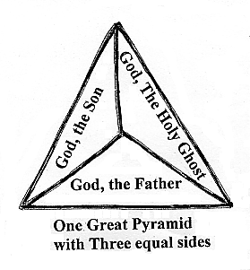

A candle: Jesus would correspond to the tangible wick, the Father to the Fire or flame, and the radiating light, to the Holy Spirit.

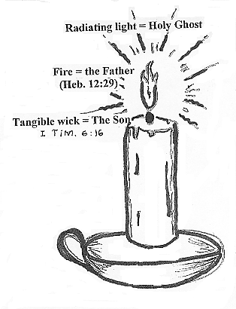
- We can compare God to the sun in the sky: It has some substance, heat, and light, corresponding the Father, Son, and Holy Spirit.

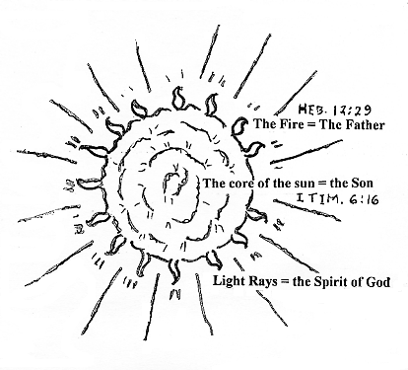
All of these are rather inept comparisons to God.

- But I think the best key to understand the union of pluralities of the Divine Godhead is to consider Gen 1:26 where God said, “And God said. Let us make man in our image, after our likeness: ...”

Now, if we work backward from that depiction we can see how the reproduction of an image is illustrated in the insignia rings which ancient kings used to press into hot wax to seal important letters.

A man consists of three parts: spirit, soul, and body as I Thes. 5: 23. says, “And the very God of peace sanctify you wholly; and I pray God your whole spirit and soul and body be preserved blameless unto the coming of our Lord Jesus Christ.”

So, I am just one human being, but I am a spirit, I have a soul, and I live in a physical body. And I was made in the image of God.

To define these three aspects of our being:

- SPIRIT- The breath, spark, or vital principal of life. The essence or mainspring of self-conscious life; The center-most animating feature of a living man.

- SOUL - the self, person, or personality embodying the feelings of the "heart' and the thoughts of the mind.

- BODY- the visible material part of a human being which normally includes the five senses of sight, hearing, touching, tasting, and smelling.

Our body also corresponds to the Jewish Temple: the common place, holy place, and the most holy place where God's Spirit inhabited.

Our body= the common place; our soul = the holy Place, and our spirit = the most holy place.

Therefore, God is a threefold Supreme Being that somehow corresponds to the three aspects of a human being.

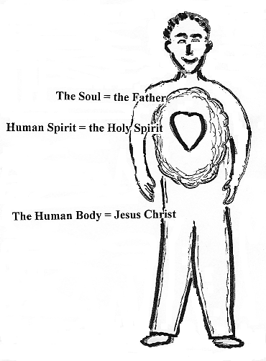
We humans are a trichotomy patterned after our Maker.

So I think my body corresponds to the Son, my spirit corresponds to the Holy Spirit, and that leaves my soul to correspond to the Father.

THE COOPERATION OF THE TRINITY

Notice that all three members of the Trinity are mentioned in the following Scripture passages:

- II Cor. 13:14 “The grace of the Lord Jesus Christ, and the love of God, and the communion of the Holy Ghost, be with you all. Amen.”

- Eph. 2:18 “For through Him (Christ) we have access in one Spirit to the Father.”

- I Pet. 1:2 “Elect according to the foreknowledge of God the Father, through sanctification of the Spirit, unto obedience and sprinkling of the blood of Jesus Christ: Grace unto you, and peace, be multiplied.”

There are many other Scriptures that indicate that there are three Persons of the Trinity. Some of them are:

At the baptism of Jesus by John in the Jordan: the Father was present by His voice, the Son was present in the water, and the Holy Spirit appeared like a Dove.

Mt. 3:16-17 And Jesus, when he was baptized, went up straightway out of the water: and, lo, the heavens were opened unto him, and he saw the Spirit of God descending like a dove, and lighting upon him: And lo a voice from heaven, saying. This is My (the Father) beloved Son, in whom 1 am well pleased.

Isaiah saw and heard the seraphim around the Throne of God crying “Holy, Holy, Holy!” (Isa. 6:2-3) — again, hinting at the Trinity.

When the O.T. calls God “The God of Abraham, and of Isaac, and of Jacob,” is that not another hint at His Trinitarianess.

Finally, we think of Matt. 28:19 which tells us to “Go ye therefore, and teach all nations, baptizing them in the name of the Father, and of the Son, and of the Holy Ghost:”

OUR DEVOTION TO GOD

Some say, the Son is separate and subordinate to the Father. Others say the Father and the Son are One and the same.

Jesus told Mary, “I ascend unto My Father, and your Father; and to My God, and your God.” Jn. 20:17

Jesus also said, “My Father is greater than I.” Jn. 14:28

The usual Scriptural designation is: “Father, Son, and Holy Spirit,” which is not necessarily a distinction of rank or degree, but a proper order. We do not say, “Here comes a woman and her husband.” but rather, “Here is a man and his wife.”
They all share the same essential attributes of Divinity and therefore equally deserve our reverence, appreciation, and adoration.
ECUMENICAL CHURCH COUNCILS
Different views threatened the unity of the Christian Church. So some minimum statement that most Christians would be able to abide by was desired, so they tried to establish a universal creed. But I doubt if any of the twelve apostles ever recited the “Apostle’s Creed.”
The doctrine of the trinity has been at the heart of much theological controversy for centuries.
During the first 1,000 years of church history, there were many doctrinal disputes among Christian leaders and bishops. Most of these were over the nature of God and the Lord Jesus Christ.
There was much difference of opinion concerning the difference and the sameness of the Father and the Son.
The Anti-Nicene fathers were all stabbing at the truth, but the early church fathers — Clement of Rome, Irenceus, Tertiollian, Origin, etc., were just as clumsy as preachers are today.
Many hundreds of Bishops through out eastern and western Rome —from Spain, Russia, Italy, Turkey, Egypt, Persia, etc., attended these councils.
313 A.D. -- The wholesale persecution of Christians ended with the edict of Milan.
325 A.D.—at the Council of Nicea they decided what books should be included in the canon of Scriptures and what manuscripts were to be excluded.
325 A.D. --The Council said that they believed Jesus Christ was “very God of very God.” Some stressed that Jesus was “begotten not made” and was one “substance with the Father.”
But Heb. 2:17 and other passages says that Jesus He was “made.”
“Wherefore in all things it behoved him to be made like unto his brethren, that he might be a merciful and faithful high priest in things pertaining to God, to make reconciliation for the sins of the people.”
Heb. 5:8-9 Though He were a Son, yet learned He obedience by the things which He suffered: And being made perfect, He became the author of eternal salvation unto all them that obey Him...” Also see Heb.1:4; 2:9; 5:5; 7:26
And as regarding “Jesus being one substance with the Father -- the word “Substance” seems to be a strange term to use to describe the great Spirit we call the Father, for a “Substance” is some mass of tangible matter or substantial material.
So then is the Holy Spirit also one substance with the Father and the Son?
381 A.D. --First Council of Constantinople dealt with the Divinity of Jesus and discussed the Trinity.
431 A.D. --The Council of Ephesus declared that Jesus was one Person with two natures.
451 A.D.-- Council of Chalcedon affirmed the full humanity of Jesus.
553 A.D. second Council of Constantinople- mostly just condemned each other.
680 A.D.-- Third Council of Constantinople decided that the divine and human nature of Jesus Christ was perfectly blended — that He was truly divine and truely Hunan.
But some leaders refuse to submit to the decisions of these councils.
1054 AD.-- Then the Roman Catholic Church finally split into east and west, called “The Great Schism.”
1517 A.D.-- The Protestant Reformation split off from the western church.
1962 A.D.-- the Roman Catholic church under Pope John the 23rd called for what became known as “Vatican II,”
The Catholic Pope claims to have all authority through succession from the Apostle Peter like Joseph Smith, Jr. claimed to have all authority through restoration from some heavenly being.
But I am not convinced that the Catholic Bishops were inspired and uncompromised men of God when you consider all the paganism that was allowed to creep into the Church; nor that the LDS have a franchise of all spiritual authority today.
When men themselves are a mixture of good and bad, their councils and doctrines are also a mixture that we cannot depend upon.
THE BLESSED HOLY SPIRIT
Some preachers neglect teaching on the Divine Godhead because it is so debatable.
And those who do teach about the Father and the Son often leave out the Holy Spirit, because He seems to be the most difficult Person of the Trinity to fully comprehend.
A ghost is a disembodied being, not just an imaginary phantom of the spiritual world.
Often the Bible simply mentions the Holy Spirit along with the Father and the Son.
The Holy Ghost is the Contractor of the creation and the Architecture of the galaxies. He is the One who actually carried out the work of creation and the working of supernatural miracles.
He is the Maker of all matter and energy. The Holy Spirit designed tiny atoms and the huge rolling orbs of the vast outer space, all on the same pattern.
The Holy Spirit is always identified with the power of God and the glory of God. God's Spirit, Power, and Glory are indivisible.
He is infinitely intelligent and essentially connected to the Father and the Son.
The Holy Spirit proceeds from the Father and the Son, as the active Agent of the Father and the Son.
He radiates and emanates forth from the Father, and the Son throughout the endless space of the universe.
The Holy Spirit of God is omni-present through out every particle of space in the universe, but He is more concentrated in us and intensified around us.
There is no empty space, for the Holy Spirit is everywhere.
He is even in hell --- regulating it, subduing the evil spirits, and restraining any excess of wicked torment down there.
Ps. 139:7-8 “Whither shall I go from Thy Spirit? or whither shall I flee from Thy presence? If I ascend up into heaven, Thou art there: if I make my bed in hell, behold, Thou art there.”
The Holy Spirit permeates everything more or less; He is the Sustainer of all things spiritual and the Upholder all things material, maintaining the order thereof.
He monitors the entire world all at once and dispatches innumerable holy Angels and tells them where to go and what to do. They love to minister, serve, and help the children of God.
At creation, we see the Spirit “moving over the face of the waters” (Gen. 1:2). The Holy Spirit brooded over the deep like a hen over her eggs.
The Holy Ghost not only hovers over the natural creation and monitors the earth, but attentively oversees all the details of your life and mine.
The Holy Spirit does the bidding of the Father and the Son. He performs the action and makes things happen according to the will of God.
Jesus spoke the Words of healing and the Holy Spirit moved forth and made the sick whole. And the Spirit still moves upon people today.
He pricks sinners in their conscience with conviction of their sins.
The Holy Spirit persuades us, but does not pressure us against our will like the devil tries to do.
He is very gentle and sensitive. He comes, moves, and goes.
The Holy Spirit influences us through impressions, promptings, checks, stirrings, guidance, and leadings.
He inspires, anoints, and gives us a holy unction from on high. He enlivens, stimulates, and causes us to develop, grow, and thrive.
He provides an energetic quickening that animates and activates us so that “...the people that do know their God shall be strong, and do exploits.” Dan. 11:32
In a moment, He can make you shout and jump and dance giving praise to Him. Ac. 3:8
The power of the Holy Spirit is often overwhelming and may cause us to swoon.
Or, He can cause a wicked person to drop dead like Ananias and Sapphira in Acts, chapter 5.
The Holy Spirit has many names or titles: Holy Spirit, Holy Ghost, Spirit of God, Spirit of Truth, the Comforter, etc.
We must never underestimate the importance and prominence of the Holy Spirit.
He is divine love, divine light, and divine life.
He rains, pours out, and flows over us in special visitations and seasons of refreshing to revive us.
The Father is referred to as a “Person.” Heb. 1: 3
Christ is called a “Person” in II Cor. 2:10
But the Holy Spirit is never called a “Person” in the Bible.
But just because the Bible never actually calls the Holy Spirit a “Person” does not prove that He is not a Person.
The Holy Spirit is a Person because He is referred to by the personal pronouns of “Him” and “He.”
The Bible does call the Holy Spirit an “It” twice.
Rom. 8:16 The Spirit itself beareth witness with our spirit, that we are the children of God:
Romans 8:26 Likewise the Spirit also helpeth our infirmities: for we know not what we should pray for as we ought: but the Spirit itself maketh intercession for us with groanings which cannot be uttered.
The Holy Spirit is not “God, the Mother” and He has no gender. The Scriptures never refer to the Spirit of God in the female gender, as a “Mother God” or goddess.
We ought to be very careful to not offend the Holy Spirit for He is like a gentle Heavenly Dove. Mt. 3:16
If we offend the Holy Spirit to a serious degree, He will forsake us temporarily or even permanently or destroy us.
Ac. 5:3-4 calls the Holy Spirit “God” saying that Ananias had lied to the Holy Spirit, that he had lied to God.
We must never resist (Acts 7:51), strive against (Gen. 6:3), lie to (Acts 5:4), quench (I Thes. 4:19), grieve (Eph. 4:30), or blaspheme (speak against) (Mk. 3:29) the Holy Spirit.
Be sensitive to Him and let Him have His way, full sway.
The Holy Spirit is like sun rays that warms the earth— it melts the wax and hardens the clay.
He can exterminate the enemies of God in a flash. But because of God's love and mercy He just leaves His foes alone sometimes. Rom. 1:24-26
The Holy Spirit holds down wicked spirits (II Pet. 2:5) and “lets” (or withholds) the Antichrist back. II Thes. 2:7
The Holy Spirit radiates and emanates from the Father and Son.
Light is a form of power that streams and shines from one place to another.
The Holy Spirit flows, waves, rolls, and can bellow or roar.
Be very sure of this: the Holy Spirit has a voice all of His own and He can and does speak freely at will.
The resonating voice of God can sound out as a trumpet to the Israelites at the foot of Mt. Sinai (Ex. 19th chapter) or whisper in a still small voice to His obedient prophet. I Ki. 19:12
The Word of God is the Sword of the Spirit, and His main tool and weapon.
MANIFESTATIONS OF THE HOLY GHOST
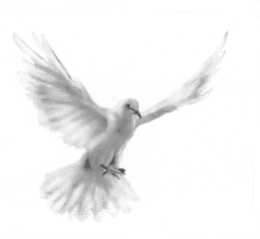
We may not be able to tell exactly where a little breeze starts or discern precisely where it teeters out — but if you’re in the midst of a tornado you can certainly feel and see the effects thereof.
Even so, the Holy Spirit is here, there and everywhere. He perks us up, moves upon us, and makes His presence and power known. He gives utterance in other tongues.
II Sam. 5:24 24. “And let it be, when thou hearest the sound of a going in the tops of the mulberry trees, that then thou shalt bestir thyself: for then shall the Lord go out before thee, to smite the host of the Philistines.”
Sometimes He rustles and swirls through the “trees” turbulently and it causes men to quake and tremble, and at other times He is so soft that He is barely discernable.
The Holy Spirit can produce a heavenly fragrance and a sweet aroma in the air.
The Holy Spirit is a little like electricity.
He moves upon God's people, makes things happen, and performs miracles.
The Holy Spirit creates things. He can multiply a sack lunch into a ton of food.
He regenerates, rejuvenates, and sanctifies us. Then, He will resurrect, transform, and glorify us.
SYMBOLS OF THE HOLY GHOST
The Bible compares the Holy Spirit to a cloud, wind, smoke, vapor, etc.
In the Scriptures, Holy Spirit is symbolized by fire, light, water, oil, and even a Gentle Dove.
The Presence of God was manifested as a visible pillar of cloud by day and appeared as a pillar of fire by night over the Tabernacle in the wilderness.
The Holy Spirit is an unapproachable, inextinguishable, all-“consuming fire.” Heb. 12:29
Fire has no natural particular shape. Even so the Holy Spirit is the shapeless essence of God.
The Holy Spirit is seen as a cloud which is a mass that has no steadfast form, but is in constant undulations.
The Holy Spirit is like rain (Joel 2:23) and is poured out upon us (Ac. 2:17-18; 10:45 ) and falls on people. Acts 10:44; 11:15)
Water is a liquid that flows. The Holy Spirit is symbolized as rain and water which is poured out upon us.
Oh, God give us a mighty revival flood to wash away all our carnality and worldliness away.
But the Holy Spirit is not just a smoke, mist, or an influence. He has and still can appear as a glory cloud, a bluish mist hanging in the air over a congregation. I saw it in my first church.
SEVEN SPIRITS
In Rev. 1:4; 3:1; 4;5; and 5:6 John writes and sends greetings to the seven churches of Asia from Him, Who was, and is, and is to come——AND from the seven spirits which are before His throne, and from the Lamb of God, Who has the seven spirits of God.
These passages also speak of seven lamps of fire before the Throne, which are the seven spirits of God. And finally they speak of the Lamb having seven horns and seven eyes, which are the seven spirits of God, which are sent forth into all the earth.
Now are these seven spirits of God seven aspects, manifestations, or expressions of the Holy Spirit or just seven great archangels?
Is. 11: 1-3 says, “And there shall come forth a rod out of the stem of Jesse, and a Branch (Jesus) shall grow out of his roots:
And the Spirit of the Lord shall rest upon Him,
1. the spirit of wisdom and
2. understanding, the
3. spirit of counsel
4. and might,
5. the spirit of knowledge
6. and of the fear of the Lord; And shall make him
7. of quick understanding in the fear of the Lord:
“...and he shall not judge after the sight of his eyes, neither reprove after the hearing of his ears:”
So we could certainly derive seven different ministries of the Holy Spirit that this could refer to (and even more.) Also, seven is the number of perfection and of course the Spirit of God is certainly perfect.
But I think it simply refers to seven great angelic spirit beings.
Jn. 20 ; 22. And when He (Jesus) had said this, He breathed on them, and saith unto them, “Receive ye the Holy Ghost:” I believe that was a command to “ALL.” Acts. 2:38-39
He is like the Breath of the Father or Son, (Jn. 20:22) but the Holy Spirit is not just so much air.
We may have the Spirit in a measure, but “God giveth not the Spirit by measure unto Him (Jesus). Jn.3:34
The anointing of the Holy Spirit fluctuates: -- heavy and intense one day and relaxing and mild the next day — Stronger one day and faint the next.
Christians are to be filled with the Holy Spirit. He envelopes or baptizes us when we obey Him (Acts 5:32), ask in faith, (Lk. 11:13), and praise Him.
I have Pastored churches where everyone was singing in the Spirit (in tongues) in such a soft and beautiful way where they made “one sound” (II Chron. 5:13) that would rise and fall. Then every one would just abruptly stop and other times they would taper off ever so gradually. Then a prophetic utterance would often come forth.
HEAVENLY HARMONY
Please consider several things now:
- Little fish in the sea swimming and shift direction in amazing synchronization.
- Birds in the sky fly around and instantly changing their course all in beautiful unison.
- Angels in heaven dancing, moving, coming and going all in such perfect harmony.
- A Spirit–filled church flowing in the Spirit in loving worship all in one accord.
The sea acts upon the fish in currents, waves, swells, and surging tides.
Schools of little fish without any known explanation switch directions in a flashing instant following their creative impulse in their natural way of life.
In the air there are gusts, breezes and up-drafts blowing on trees and things and the air effects the birds.
Flocks of fowl in flight swirl around on air currents and all change directions in an instance --- in the twinkling of an eye with no certain leader in unending patterns.
Jesus said, “The wind blows where it wills, and thou hearest the sound thereof, but canst not tell whence it cometh, and whither it goeth: so is every one that is born of the Spirit.” Jn. 3:8
All the angels, glorified saints, and even little children in the celestial nursery seemed to be “aimlessly playing, running and romping.” But when Marietta Davis was elevated up to a higher level she could see that rather than any kind of disorder or independent movement, they were all led by the Holy Spirit, just like the bird in the sky and the fish in the sea. They were all being influenced by the invisible Holy Spirit of Almighty God.
An orchestra may have ever so many musicians each skillfully playing on their own instrument rather than independently making a noise as II Chron. 5:11-14 says.
The Lord told David, “... when thou hearest the sound of a going in the tops of the mulberry trees, that then thou shalt bestir thyself:... “for then shall the Lord go out before thee, to smite the host of the Philistines.”
Just like the fish in the sea, the birds in the sky, and the angels before the Throne; so we should loosen up, start swaying to the music, and get “in the Spirit.”
On the Day of Pentecost, they heard the sound of a rushing mighty wind. Acts 2:2
The Holy Spirit can sweep, swish, or swoosh through a congregation of worshippers in a dazzling fashion and they swoon like cut stalks of wheat.
Remember “in Him we live, and move, and have our being.” (Acts 17:28) We exist in the Holy Ghost.
Yield ourselves to the Spirit and go with the flow, whichever way He may lead and guide us.
Oh, let all the saints in church worship services behave just like the fish and birds and angels, that God may see from His exalted perspective the harmony and unity and cooperation of every member moving in the perfect well-pleasing will of God.
Some may even begin to jump and dance, or run around the tent while the Holy Ghost music constantly saturates the atmosphere with Heavenly energy. Ah, music —the universal language!
No wonder Satan tries to misuse it to stimulate the base instincts of the fallen flesh of mankind.
If you’re stirring up clean pure water it is wonderful but if Satan stirs up foul and filthy water to enflame women unto sexual lust and men unto violence and vandalism then it is like hell swelling and boiling in its own vomit and stinking sewage.
HE INDWELLS OUR BODY
Jesus said, “He that believeth on Me, as the Scripture hath said, out of his belly (innermost being) shall flow rivers of living water. But this spake He of the Spirit, which they that believe on Him should receive...” Jn. 8;38
The Holy Spirit dwells within God’s obedient children, but He departs from the rebellious.
His sweet presence concentrates around us and His loving essence intensifies within us.
We can feel the “heart beat” of God as pulsating power surging through our being.
The Holy Spirit is streams of living water that bubbles up in our bosom and gushes out of our mouth in unknown tongues or a torrent of prophetic utterance.
Oh, let us link up our heart and mind with God through the written Word and His Spirit within us.
May the mind of God communicate with our mind through the instrumentality of His Divine revelation that we may understand His ideas, will, and plans for our lives on a daily basis.
The more we digest His Word AND pray in the Spirit, the more we spiritually thrive and flourish in God.
When we are 100% in tune with the Father, in step with Christ, and in one accord with the Spirit, moment by moment, oh what joy unspeakable and full of glory it is.
THE WORK OF THE HOLY SPIRIT
The Holy Spirit is so powerful. He has a strong effect upon those who yield unto Him. He:
- Executes God's decrees.
- Fulfills the Father’s will
- Is the agent of Heaven's purpose.
- Carries out God’s plans.
- Accomplishes the works of God
- Wields the Sword of the Spirit.
- The Holy Spirit breaths upon us, as one would blow upon cinders to rekindle a flame.
- He supports and strengthens the servants of God.
- The Holy Spirit encourages us, but He is a perfect Gentleman.
- Works, operates, and activates the promises of God in our lives.
- The Spirit moves upon, guides, directs, and leads us.
- He nudges, prompts, checks, sways, stirs us.
- The Holy Spirit animates those who obey Him, and
- Causes the Gifts to operate through us for the glory of God.
The Holy Spirit monitors the whole earth all at once and dispatches multitudes of angels to wherever they are needed most. They obey instantly, travel at the speed of thought, and serve perfectly.
God’s Spirit:
- protects us from demons
- shields us from attacks
- wards off entrapments
- routs the enemy forces
- defends little children
- performs notable feats
- masters dangerous situations
- produces permanent results
THE HOLY SPIRIT IS INVOLVED IN EVERYTHING. HE FACILITATES:
- God's light for earth's darkness
- God's love for man's hatred
- Heaven's justification for earth's condemnation
- God's salvation for man's damnation
- God's joy for my sorrow
- God's grace for my guilt
- God's comfort for my grief
- God's wisdom for my confusion
- God's peace for the world's madness
- God's answer for the world's problems
- Heaven's hope for earth's despair
- God's strength for my weakness
- Heaven's life for earth's death
- Heaven's riches for earth's poverty
- Heaven's happiness for the world's misery
- Heaven's beauty for the world's ashes
JESUS, the GOD-MAN
This book is all about the three Persons in the Trinity and the two natures of Jesus Christ, the second Person of the Trinity.
The Lord Jesus Christ had both a human nature and a Divine nature, but Jesus had an unfallen human nature, like Adam did before the fall.
The name “Son of Man” is used about twice as often as the “Son of God” in the four Gospels.

The name “Jesus” appears 605 times in the Gospels; and the name “Christ” appears 60 in the Gospels.

The fourth Gospel of John uses the name “Jesus” 10 times as much as the name “Christ.”

Now, our Lord Jesus Christ is only ONE PERSON, NOT TWO PERSONS. And He had only one incarnation. There was never any divine incarnation before or after Jesus of Nazareth. The Book of Jasher (Josh. 10:13; II Sam. 1:18) plainly states that Melchisedec was Shem.

Now, I am not trying to formulate some new doctrinal idea, but for convenience sake in this study I would like to use the name “JESUS” to designate the Human side of our Saviour, and the Name “Christ” to refer to His Divine side. OK? Let me say it this way:

Christ was eternally co-existent with the Father from all eternity.
Jesus was begotten on earth about 2,000 years ago.

Christ was the Logos, Who was in the beginning with God.
Jesus was born as a Jewish peasant in Bethlehem.

Christ had no earthly parents.
Jesus had a mother, but no earthly father.

Christ, the Eternal Logos was uncreated.
Jesus was a mortal man born on this planet.

Christ cannot be tempted with evil. Ja. 1:13
Jesus, as mortal Man, was tempted as us, but never sinned. Heb. 4:15

The Immortal Christ cannot die, for He is Life itself.
Jesus was a mortal and could die and He experienced death for us.

Christ, as God in the flesh, had all power in heaven and earth.
The Man, Jesus of Nazareth was limited in time and space. He suffered hunger, thirst, and pain.
Can God be killed even for a minute? If Jesus was God how could He die?
Christ was God in the flesh and He was perfect and could not become perfect.
But Jesus “Though He were a Son, yet learned He obedience by the things which He suffered; And being made perfect, He became the Author of eternal salvation unto all them that obey Him;” Heb. 5:8-9

Jesus did not develop into divinity or evolve into godhood.
His divinity was full and complete even though the infant Jesus may not have fully realized it yet.
As Jesus grew up from a baby to a boy and then to a man, He was more and more filled with the divinity of God until at the end of His earthly life, the Divine Christ completely dominated the human Jesus.
His Godhood totally swallowed up His humanity so that He became not only One with the Father, but it is perfectly proper to say that He is the Father and the Son.
Paul, the Apostle, was separated unto the Gospel of God, which He promised in the Holy Scriptures, concerning His Son Jesus Christ , our Lord, Who as to His human nature was a descendent of David, but Who through the Spirit of holiness was shone to be the Son of God by His resurrection from the dead. See Rom. 1:1-4
JESUS AS MAN
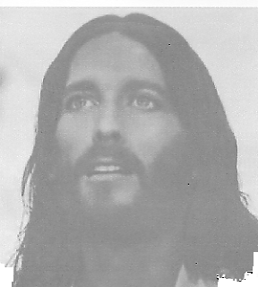
The Messiah could have just descended from heaven as a full grown man, and some O.T. Jews thought that He would, but instead He came into the world just like you and me, except that His mother was a virgin.
The Holy Spirit of God came upon the virgin Mary and supernaturally created a pure male sperm
within her, thus, impregnating her without intercourse so that she could bring forth the Holy Child,
Jesus. Ac. 4:27, 30
Mary gave birth to a man-child, Jesus of Nazareth. But He did not really grow up into “normal” manhood. He was different.
Jesus had a human nature, but not a fallen nature. His nature was like Adam before the fall.
The first Adam was created innocent, but then he sinned and fell. The Second Adam, Jesus, was sinless and did not fall.
Jesus, the second Adam, was the one and only flawless, unfallen, and perfect man.
The first Adam brought the curse of a morally depraved nature upon all men. The second Adam, Jesus provided regeneration, restoration, and salvation for all believers.
The first Adam brought death and damnation upon all men.
The second Adam brought the redemption and the resurrection upon all His followers.
Jesus had the Gift of the Word of Knowledge and He knew many things about what men were thinking. He knew who His friends and enemies were. But He also asked many questions, so He was not constantly and totally omniscience during the days of His flesh.
In order to furnish a sacrifice for sin, as the Lamb of God, Jesus had to die. He provided an infinite Atonement for all who would come to Him in faith.
CHRIST AS DIVINE
Many people today do not believe in the Divinity of Christ, such as the “Jehovah Witnesses,” “The Way International” and all other cults. Even the Utah “Mormons” believe that Christ had a beginning.
Christ, the Eternal Logos had no beginning, for He was co-eternal with the Father. Christ was, is, and always shall be the Logos, the Word, the Expression, the Thing of God.
There was never a time when Christ did not exist. Isa. 9:6 calls Jesus Christ the Everlasting Father.
Is. 9:6 For unto us a child is born, unto us a son is given; and the government shall be upon his shoulder: and his name shall be called Wonderful, Counsellor, The mighty God, the everlasting Father, The Prince of Peace.
In Jn. 5:18, Jesus was accused of making Himself equal with the Father. But the Son thought it not robbery to be equal with God. Phil. 2:6
Note that the blood of God saves us according to Acts 20:28 “..the church of God, which He hath purchased with His own blood.
Christ is the Almighty! Rev. 1:8 “I am Alpha and Omega (the A and the Z), the beginning and the ending, saith the Lord, which is, and which was, and which is to come, the Almighty.”
If Christ is not God, then it is blasphemy to worship Him.
Christ is now omni-present according to Mt. 28: 20 “lo, I am with you alway, even unto the end of the world. Amen.”
Heb. 13:8 Jesus Christ the same yesterday, and to day, and for ever
THE BIBLE SAYS THAT GOD, THE FATHER, IS INVISIBLE
Heb. 11; 27. By faith he forsook Egypt, not fearing the wrath of the king: for he endured, as seeing Him Who is invisible.
I Tim. 1: 17. Now unto the King eternal, immortal, invisible, the only wise God, be honour and glory for ever and ever. Amen.
Jn. 1:18 No man hath seen God at any time; the only begotten Son, which is in the bosom of the Father, he hath declared him.
Col. 1:15 (Christ) Who is the image of the invisible God, the firstborn of every creature:
Jn. 14: 9 Jesus saith unto him. Have I been so long time with you, and yet hast thou not known Me, Philip? he that hath seen Me hath seen the Father; and how sayest thou then, Shew us the Father?
Heb. 1: 2-3 “...His Son, whom He hath appointed heir of all things, by whom also He made the worlds; Who being the brightness of His glory, and the express image of His person..”
8. But unto the Son he saith. Thy throne, O God, is for ever and ever; a sceptre of righteousness is the sceptre of thy kingdom.
9. Thou hast loved righteousness, and hated iniquity; therefore God, even thy God, hath anointed thee with the oil of gladness above thy fellows.
Jesus is the Express Image of God and the only express Image of God. There is none other. Let's try to define that. How about:
- the projected form
- the perceivable effigy
- the visible picture
- the seeable humanoid figure

JESUS WAS FULLY HUMAN
Matt. 1:1, 18-25; 4:2; 26:38; Luke 1:26-38; 9:58; 22:44; John 1:14; 11:33-35; 19:28, 34; Romans 9:5; 1 Cor. 15:3; Gal. 4:4; Phil. 2:5-11; 1 Tim. 2:5; 3:16; Heb. 2:14-15, 17-18; 4:15; 10:5; 1 Peter 2:24; 1 John 4:2; 2 John 7.

CHRIST IS FULLY DIVINE
Isa. 9:6; Matt. 11:27; 16:16; Mark 2:5-7; Luke 5:20-22; 9:20; John 1:1; 1:14; 2:19, 21; 3:13, 31; 5:18; 6:38; 8:58; 9: 38; 10:17; 10:30; 13:3; 14:9; 14:23; 16:15; 16:28; 17:8; 17:21-23; 20:28; Romans 9:5; 1 Cor. 10:3-4; 15:47; 18:4-6; 2 Cor. 8:9; Phil. 2:5-11; Colossians 1:15-17, 19; 2:9; 1 Tim. 1:17; 2:5; Titus 2:13; Heb. 1:2-3, 8-11; 2:7, 9, 14, 16; 13:8; 1 John 5:20; Rev. 1:8, 17; 2:8; 3:14.
WE ARE IN HIS IMAGE
A sinner has only one nature --- born into and bent on sin. But as a born again Christian we have been made a partaker of the Divine Nature of the Lord.
II Pet. 1:4 -Whereby are given unto as exceeding great and precious promises: that by these ye might be partakers of the divine nature...”
We Christians still have our old nature and also a new nature, so being dualistic we have internal conflicts sometimes. Therefore our old fallen Adamic nature is to be mortified and crucified so our new divine nature may reign.
Now, just as Bible teaches that we Christians are to submit our flesh nature unto our newly implanted divine nature, ---in the same way the Son submitted Himself unto His Father. I Cor. 15:28
AND NOW A LITTLE EXTRA-BIBLICAL REVELATION ON THE DIVINE GODHEAD

Jesus was the Great Creator and first came among
the Jews of Jerusalem and died for all men

“Yea, and I know that ye know that in the body He shall show Himself unto they at Jerusalem from whence we came, For it is expedient that it should be among them;
“For it behooveth the great Creator that He suffereth Himself to become subject unto man in the flesh and die for all men, that all men might become subject unto Him; II Nephi 6: 8-10

Man was created in the image of God, then God took on the image of man.

“And because he saith unto them that Christ was the God, the Father, of all things, And saith that He should take upon Him the image of man, And it should be the image after which man was created
in the beginning—
“Or in other words, he said that man was created after the image of God, And that God should come down among the children of men and take upon Him flesh and blood and go forth upon the face of the earth; And now because he said this, they did put him to death. And many more things did they do which brought down the wrath of God upon them;” Mosiah 5:44-46a

The Eternal God dwelt in a tabernacle of clay and worked mighty miracles.
He suffered to provide salvation through faith and rose again.

“For behold, the time cometh and is not far distant, that with power the Lord Omnipotent who reigneth, which was and is from all eternity to all eternity, Shall come down from heaven among the children of men, And shall dwell in a tabernacle of clay, And shall go forth amongst men, Working mighty miracles, such as—healing the sick, raising the dead, causing the lame to walk, the blind to receive their sight, and the deaf to hear, and curing all manner of diseases; And He shall cast out devils, or the evil spirits, which dwelleth in the hearts of the children of men.
“And lo, He shall suffer temptations and pain of body, hunger, thirst and fatigue, even more than man can suffer, except it be unto death;
“For behold, blood cometh from every pore, so great shall be His anguish for the wickedness
and the abominations of His people.
“And He shall be called Jesus Christ, the Son of God, the Father of heaven and of earth, the Creator of all things from the beginning; And His mother shall be called Mary;
“And lo, He cometh unto His own that salvation might come unto the children of men, even through faith on His name.
“And even after all this, they shall consider Him as a man and say that He hath a devil, And shall scourge Him and shall crucify Him,
“And He shall rise the third day from the dead; And behold, He standeth to judge the world.”
Mosiah 1: 97-105

Jesus came to fulfill all the prophecies and to do the will of the Father.
A sign was given of His birth.

“Behold, I come unto My own to fulfill all things which I have made known unto the children of men
from the foundation of the world, And to do the will both of the Father and of the Son— of the Father because of Me, and of the Son because of My flesh.
“And behold, the time is at hand, And this night shall the sign be given. And it came to pass that the words which came unto Nephi were fulfilled according as they had been spoken.” III Nephi 1:14-16

There is only one true and living God.
The son of god came to save his people from sin.
He brings to pass the resurrection from the dead.
The father, Son, and holy Spirit is One Eternal God.

“And Zeezrom saith unto him: “Thou sayest there is a true and a living God?”
And Amulek saith: “Yea, there is a true and a living God.”
Now Zeezrom saith: “Is there more than one God?”
And he answered:” No.”
Now Zeezrom saith unto him again: “How knowest thou these things?”
And he saith: “An angel hath made them known unto me.”
And Zeezrom saith again: “Who is He that shall come? Is it the Son of God?”
And he said unto him: “Yea.”
And Zeezrom saith again: “Shall He save His people in their sins?”
And Amulek answered and said unto him: “I say unto you He shall not, for it is impossible
for Him to deny His word.”
“Now Zeezrom saith unto the people:” See that ye remember these things, for he saith there is but one God; Yet he saith that the Son of God shall come, but He shall not save His people, as though he had authority to command God.”
“Now Amulek said again unto him: “Behold, thou hast lied, for thou sayest that I spake as though I had authority to command God because I said He shall not save His people in their sins.
“And I say unto you again, that He cannot save them in their sins, for I cannot deny His word,
“And He hath said that no unclean thing can inherit the kingdom of heaven; Therefore, how can ye be saved except ye inherit the kingdom of heaven? Therefore, ye cannot be saved in your sins.”
“Now Zeezrom saith again unto him: “Is the Son of God the Very Eternal Father?”
‘And Amulek saith unto him: “Yea, He is the Very Eternal Father of heaven and of earth and all things which in them is; He is the beginning and the end, the first and the last;
“And He shall come into the world to redeem His people; And He shall take upon Him the transgressions of those who believe on His name, And these are they that shall have eternal life;
And salvation cometh to none else.
“Therefore, the wicked remain as though there had been no redemption made, except it be
the loosing of the bands of death.
“For behold, the day cometh that all shall rise from the dead and stand before God and be judged
according to their works.
“Now there is a death which is called temporal death; And the death of Christ shall loose the bands
of this temporal death, that all shall be raised from this temporal death;
“The spirit and the body shall be reunited again in its perfect form; Both limb and joint shall be restored to its proper frame, even as we now are at this time;
“And we shall be brought to stand before God, knowing even as we know now, and have a bright recollection of all our guilt.
“Now this restoration shall come to all—both old and young, both bond and free, both male and female, both the wicked and the righteous;
“And even there shall not so much as a hair of their heads be lost, But all things shall be restored to its perfect frame, as it is now, or in the body,
“And shall be brought and be arraigned before the bar of Christ the Son and God the Father and the
“Holy Spirit, which is one Eternal God, To be judged according to their works, whether
they be good or whether they be evil.” Alma 8: 79-104

Jesus is called the Son because He dwelt in the flesh;
and He is the Father after the Spirit,
thus He is the Father and the Son.
The Son is subject to the Father as the flesh is subject to the spirit.

“And now Abinadi saith unto them: “I would that ye should understand that God Himself shall come down among the children of men and shall redeem His people; And because He dwelleth in flesh, He shall be called the Son of God;
“And having subjected the flesh to the will of the Father, being the Father and the Son—The Father, because He was conceived by the power of God, and the Son, because of the flesh, thus becoming the Father and Son, And They are one God, yea, the Very Eternal Father of heaven and of earth—
“And thus the flesh becoming subject to the Spirit, or the Son to the Father, being one God, suffereth temptation and yieldeth not to the temptation, But suffereth Himself to be mocked and scourged and cast out and disowned by His people.
“And after all this, and after working many mighty miracles among the children of men, He shall be led, yea, even as Isaiah said—‘As a sheep before the shearer is dumb, so He opened not His mouth’— Mosiah 8: 28-33

A man at the time of the Tower of Babel saw the finger of the Lord;
And he saw the spiritual (pre-incarnate) body of Jesus by faith.

“And it came to pass that when the brother of Jared had said these words, Behold, the Lord stretched forth His hand and touched the stones one by one with His finger; And the veil was taken from off the eyes of the brother of Jared and he saw the finger of the Lord, And it was as the finger of a man— like unto flesh and blood; And the brother of Jared fell down before the Lord, for he was struck with fear.
“And the Lord saw that the brother of Jared had fallen to the earth, And the Lord said unto him:
“Arise, why hast thou fallen?” And he saith unto the Lord: “I saw the finger of the Lord and I feared lest He should smite me, For I knew not that the Lord had flesh and blood.”
“And the Lord said unto him: “Because of thy faith thou hast seen that I shall take upon Me flesh and blood; And never has man come before Me with such exceeding faith as thou hast; For were it not so, ye could not have seen My finger—Sawest thou more than this?”
“And he answered: “Nay, Lord, show Thyself unto me.” And the Lord said unto him: “Believest thou the words which I shall speak?”
“And he answered: “Yea, Lord, I know that Thou speakest the truth, For Thou art a God of truth and canst not lie.”
“And when he had said these words, Behold, the Lord showed Himself unto him and said:
“Because thou knowest these things, ye are redeemed from the fall; Therefore, ye are brought back into My presence; Therefore, I show Myself unto you.
“Behold, I Am He which was prepared from the foundation of the world to redeem My people;
“Behold, I Am Jesus Christ, I Am the Father and the Son; In Me shall all mankind have life and that eternally, even they which shall believe on My name, And they shall become My sons and My daughters; And never hath I showed Myself unto man whom I have created, For never hath man believed in Me as thou hast.
“Seest thou that ye are created after Mine own image? Yea, even all men were created in the beginning after Mine own image;
“Behold, this body which ye now behold is the body of My Spirit; And man have I created after the body of My Spirit; And even as I appear unto thee to be in the Spirit, will I appear unto My people in the flesh.”
“And now as I, Moroni, said I could not make a full account of these things which are written,
“Therefore, it sufficeth me to say that Jesus showed Himself unto this man in the Spirit, even after the manner and in the likeness of the same body, even as He showed Himself unto the Nephites;
“And He ministered unto him, even as He ministered unto the Nephites; And all this that this man knew that He was God, because of the many great works which the Lord had showed unto him; And because of the knowledge of this man, he could not be kept from beholding within the veil;
“And he saw the finger of Jesus which when he saw, he fell with fear, for he knew that it was the finger of the Lord; And he had faith no longer, for he knew, nothing doubting; Wherefore, having this perfect knowledge of God, he could not be kept from beholding within the veil; Therefore, he saw Jesus, And He did minister unto him.” Ether 1: 68-85

NOTE
Apparently the kind of body that Jesus had before His incarnation was like the body that He had after His resurrection. He could suddenly appear and disappear, or materialize and dematerialize. Angels also are able to do physical things and then vanish.
The glorified saints will also have this kind of body at the resurrection.

The above is taken from the Restored Covenant Edition of the Record of the Nephites, which were a “Lost’ branch of the Tribe of O.T. Joseph. They lived in America from 600 BC to 421 AD and were the ancient ancestors of the Native Americans.
The inspired record was discovered and translated in 1830,
but unfortunately is now in the hands of the so-called “ Mormons.”
CONCLUSION
Now, the difference between the Father, Who is a Spirit and the Holy Ghost, Who is also a Spirit, is that the Holy Spirit is diffused throughout all space of the universe, being omnipresent; whereas the Father, as the “Hub” of all existence, is the centralized, stationary Spirit in the exact center of the universe.
The Father is the constantly abiding Presence of God ever presiding and ruling upon His Great White Throne in the midst of the highest heaven, in charge of and in control of all His works.
Through our Lord Jesus Christ we come to know God, the Father, whom the Bible calls invisible. In His life and death, Jesus “declared” the God, Who is love, light, and life. Jn. 1:18
So Jesus is the prime revelation, exact representation, and the very Personage of the Father.
The Invisible Father and the Holy Spirit are both “Spirit” and therefore do not have a corporal body, other than the Lord Jesus Christ, Who is therefore the visible bodily form of the Godhead.
Lk. 24:39 “... a spirit hath not flesh and bones...”
The Holy Spirit has no physical or visible body form, other than the Lord Jesus, inasmuch as Christ Himself is the Body of the Godhead Trinity.
Col. 2:9 9. “For in Him (Jesus) dwelleth all the fulness of the Godhead bodily.”
In other words, I think the Father and the Holy Spirit are without a physical body other than the Lord Jesus Christ, Who is the Visible Image of the Father and the Holy Spirit.
Now I have read a number of accounts of people who have gone to heaven and said that they did see the Father on His Throne, but most of them say that they mainly just “sensed” His Presence rather than scrutinized His features, for He was covered in a very bright glory cloud. I do not deny their experience.
Jesus Christ was and is the Human form and seeable expression of God. There is only one physical Body of the Godhead, Jesus Christ.
In a way, it is like: Anywhere the Father glances or fixes His gaze, there He instantly projects a three-dimensional hologram of His own image, which is Jesus Christ; and yet, the Father is all-seeing, so can see everywhere at once, and thus Jesus can appear to be with everyone, everywhere, all the time, as He promised.
The Holy Ghost is the Spirit of the Father, and the Holy Ghost is also the very Spirit of the Son.
So I like to think that inasmuch as I pray and believe and obey God, that the Father is always watching over me, Jesus is always with me as my constant Companion, and the Holy Spirit is within me.
Heb. 1:3 says that the Son of God is the brightness of God’s glory, and the express image of His Person. He is also:

- The Incarnation of His Very Being.
- The Manifestation of His nature.
- The Reflection of His character.
- The Revelation of His heart.
- The Evidence of His care.
- The Display of His intelligence.
- The Declaration of His truth.
- The Explanation of His wisdom.
- The Demonstration of His power.
- The Upholder of His righteousness.
- The Sweetness of His salvation.
- The Evidence of His greatness.
- The Preserver of His Majesty.
- The Example of His Serenity.
- The Embodiment of His presence,
- The Fulfillment of His will.
- The Demonstration of His love.
- The Proof of His goodness.
- The Supplier of His grace.

OTHER BOOKS BY THE SAME AUTHOR

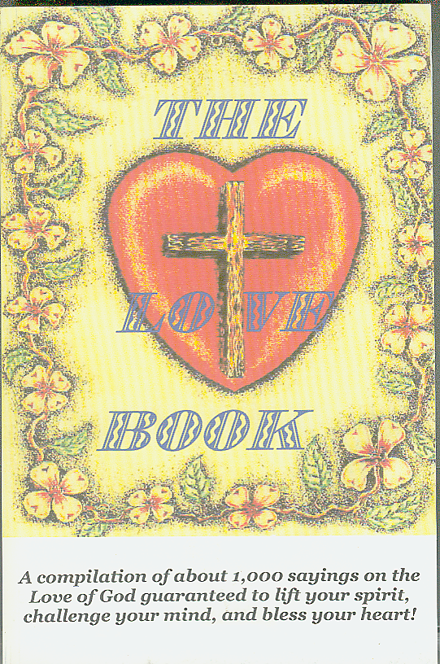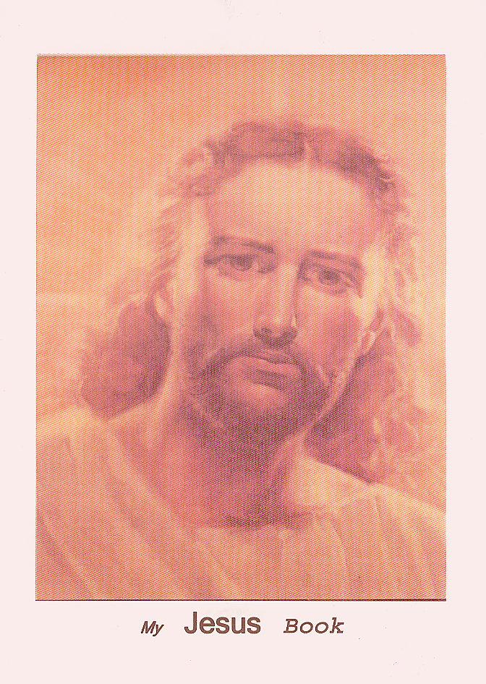

THE LOVE BOOK is 5.5” x 8.5” and contains 1,000 sayings on the Love of God.
It sells for $5.97
MY JESUS BOOK is 8.25”x10.5” and contains 144 pages. It sells for $7
Please include $1 @ book for postage & handling.
Call for discount prices on large orders. Thanks.

This book is also COURSE IX of The Spirit of Truth Institute
and has an accompanying Examination Book,
by which you can earn an accredited degree.

Just contact us and order the Examination book.

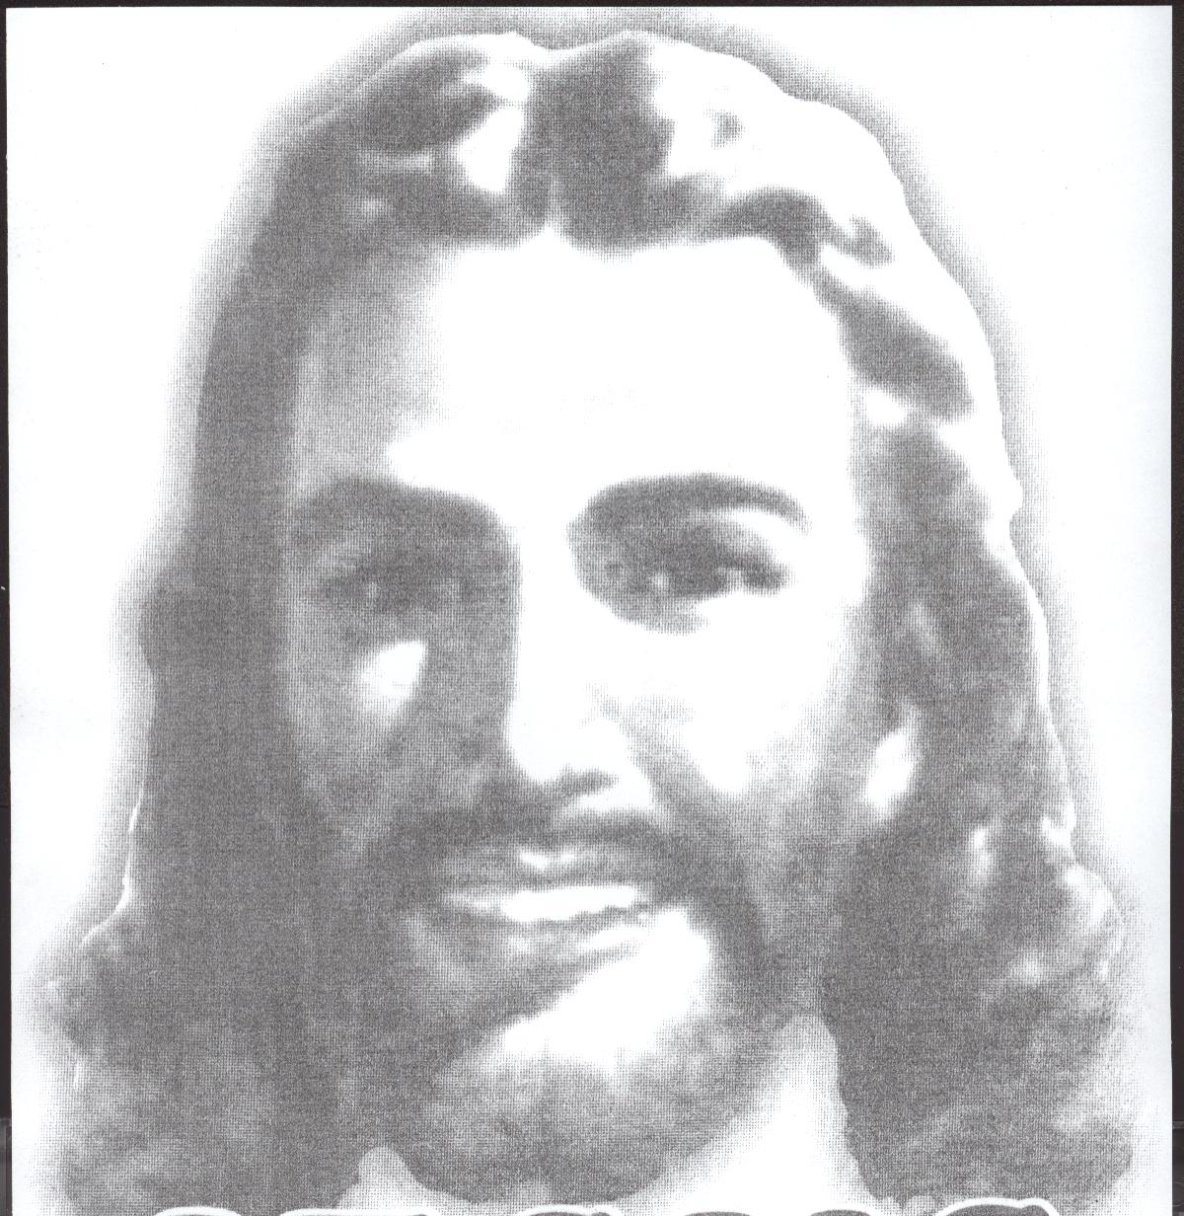

MINISTERIAL RESOURCES AVAILABLE

